DRC

District Resource Centre (DRC):
- Established in 23 Districts ID Colleges in 2007-08.
- Pooling and sharing of Resources to the advantage of students of all the Colleges in the District.
- Activities like conducting Guest Faculty Lectures, Student Seminars and Training Programes.
- Academic Support to the Students of Rural Colleges.
- A Platform for Joint Participatory Academic and Cultural Activities for students as well Teachers at the District Level.
- All the GDC's of District are memebers of DRC.

Suggested Activities
The activities shall be at the district level and the participation of students from all colleges, rural colleges in particular of the district. The Lecturer/principal of the college concerned shall choose the participating student teams. The other guidelines can be finalized in the DRCs itself. The activities shall give clear, visible and quantifiable benefits to students.
- Conducting district level seminars, expert lectures, panel discussions, academic competitions, career guidance programmes etc.
- Organizing short-term summer programmes, certificate courses, training programmes,workshops etc.for improving various skills of students, including communicative, soft and ICT skills and job/self employment oriented skills
- Special training for preparing students for competitive examination for higher studies, research institutes, employment etc.
- Visits of eminenet scientists, social scientists,industrialists;experts etc.for interaction with staff and students for creating the required awareness
- Conducting value based activities, cultural programmes, youth festivals, exhibitions etc.
- Exchange of faculty for short term teaching programmes and conduct of practicals
- Sharing of facilities by the other college students(where there are no such facilities) without affecting the routine of the host college
- Exchange of students to working teams for carrying out educational surveys, study projects, field work, hands on experience etc.
- Pooling of students for talking up of community service works
- Activities that are consequential to the schemes and programmes intiated at the Commissionerate level like JKCs, ETRP(ELF),NAAC/QAC activities, Repositioning, Training programmes, ManaTV etc
District Resource Centre

It is here by inform to all the lectures and students that there will be a program on DISTRICT RESOURCE CENTRE i.e. on 14-09-2022 in view of creates awareness among the Direct Resource Centre at 11:30 a.m. at seminar hall. Moreover, all the lectures and Students should participation the event.

Principal

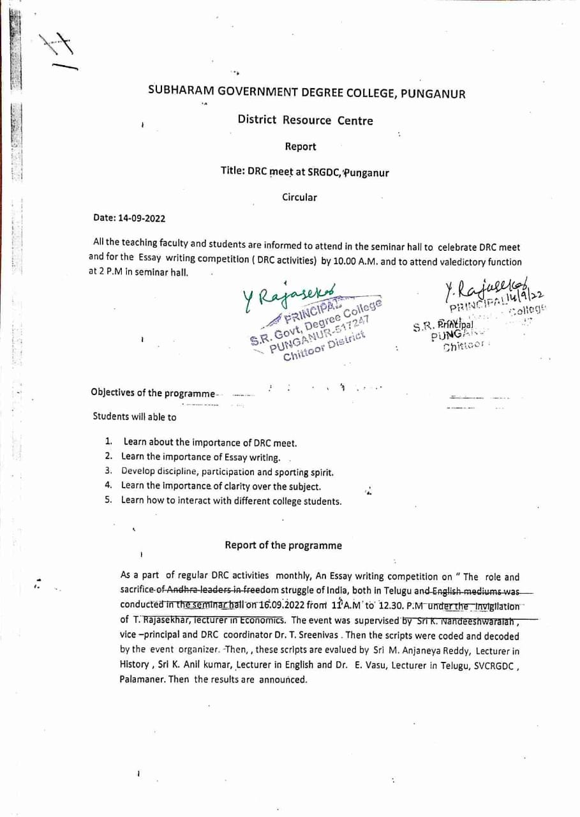
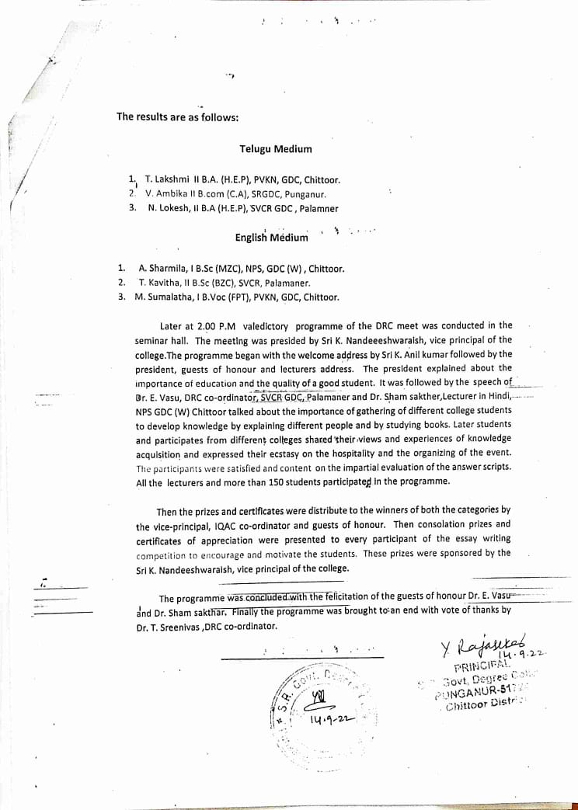
Photos
